Web Application Firewall (WAF) Home Lab Safeline WAF + DVWA
- Introduction:
This project documents the design and deployment of a self-hosted **Web Application Firewall (WAF)** home lab, built to demonstrate practical, hands-on web application security skills, attack simulation, defense configuration, and log analysis.

The lab simulates a realistic attacker-vs-defender scenario:
-A **vulnerable web application** (DVWA — Damn Vulnerable Web Application) is deployed on an Ubuntu server, standing in for a production web app with known weaknesses (SQL injection, XSS, etc.).
- A **web application firewall** (SafeLine WAF) sits in front of it as a reverse proxy, inspecting and filtering traffic before it reaches the app.
- A **Kali Linux** machine plays the attacker, launching real exploitation attempts against the app — first with the WAF disabled (to confirm the vulnerability), then with it enabled (to confirm the WAF blocks it).

Objectives:
- Stand up a vulnerable web app in a controlled environment.
- Deploy and configure a production-grade WAF (SafeLine) as a reverse proxy.
- Demonstrate SQL injection being exploited, then blocked, with log evidence.
- Configure and test additional WAF defenses: HTTP flood/rate limiting, authentication gateway.

Skills demonstrated:

Virtualization & networking · Linux administration (Ubuntu + Kali) · LAMP stack deployment · DNS resolution (`/etc/hosts`) · SSL/TLS certificate generation · Reverse proxy configuration · WAF policy tuning · SQL injection · Rate limiting/anti-DoS · Log analysis

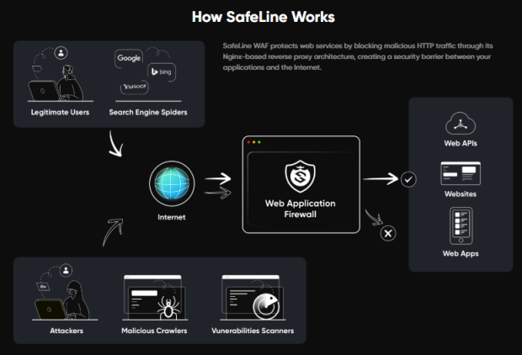
Figure 1 How safeline works

Phase 1: Network Setup:
At First I made sure that both the VMs kali and ubuntu are on the same network adapter for this I used the Bridged mode for both VMs.
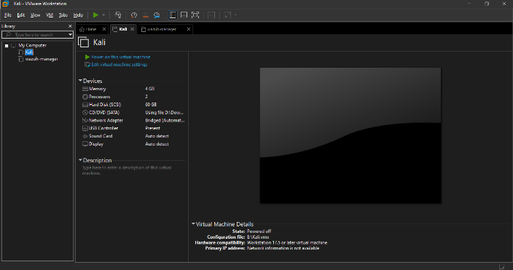
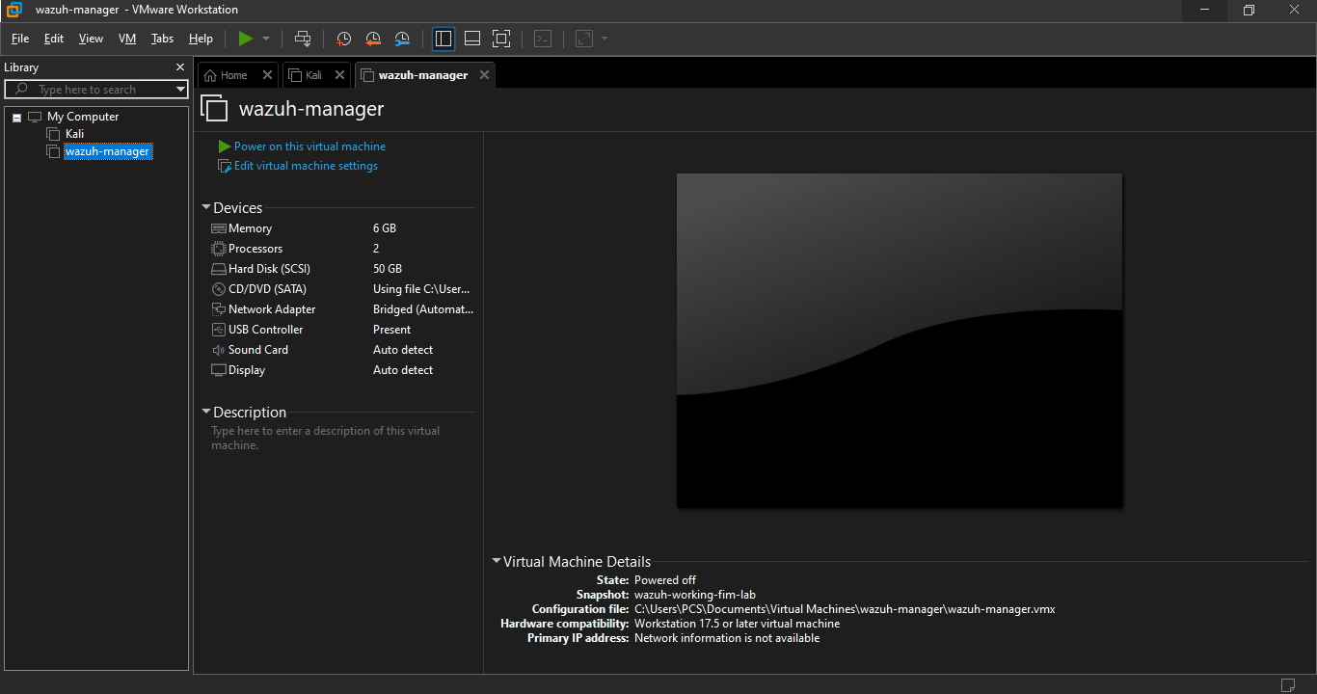
Figure 2 kali
Figure 3 ubuntu
then to check both VMs are on the same network adapter run these commands to check there Ips
Ifconfig and ip a

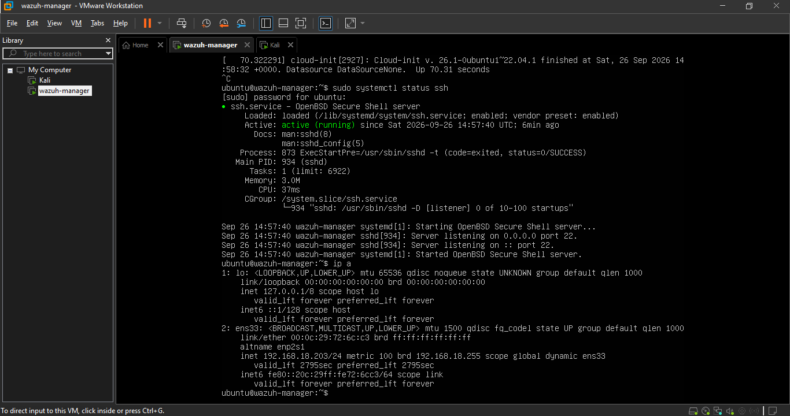
Figure 4 ubuntu Ip address
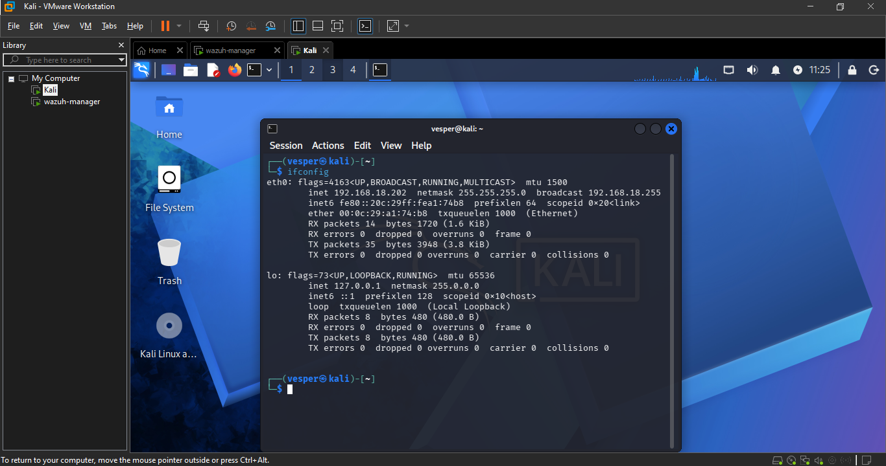
Figure 5 kali Ip address
To test the connectivity run these commands
# From Kali:
ping <Ubuntu-IP>

# From Ubuntu:
ping <Kali-IP>
When I used these command on both VMs they show zero packet loss which means both the VMs are on the same network adapter.
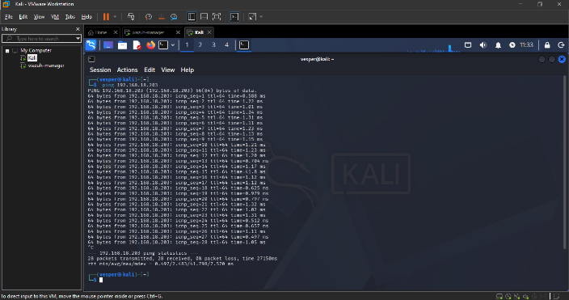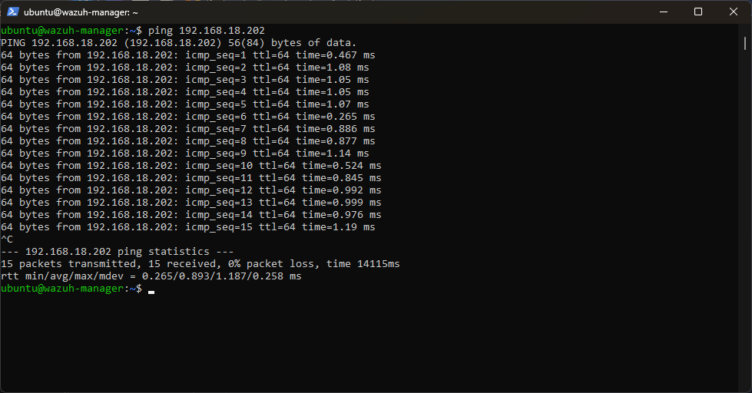
Verify: ping <Ubuntu-IP> from Kali and ping <Kali-IP> from Ubuntu both show 0% packet loss.

Phase 2: LAMP Stack + DVWA (on Ubuntu, via SSH):
1. Update and install prerequisites:
I updated and install the prerequisites on ubuntu via SSH for this I used these commands:
sudo apt update && sudo apt upgrade -y
sudo apt install -y net-tools openssl git
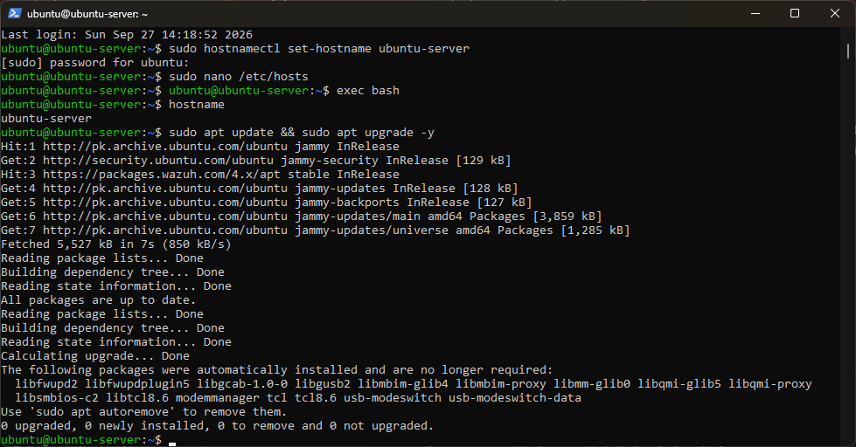
Figure 6 ubuntu update and upgrade
2. Install Apache, PHP, MySQL:
After updating and installing prerequisites I installed Apache, PHP, MySQL on ubuntu server.
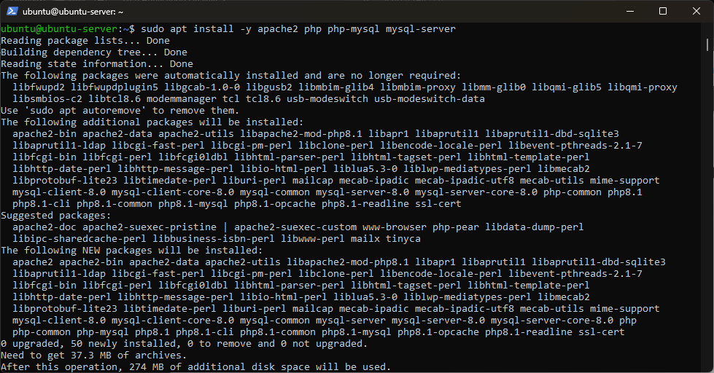
Figure 7 installing Apache, PHP, MySQL
3. Secure MySQL (optional but recommended):
After making sure that the installation is complete I run this command to unsure the secure SQL installation.
sudo mysql_secure_installation
I followed the following prompts: set a root password, remove anonymous users, disable remote root login.
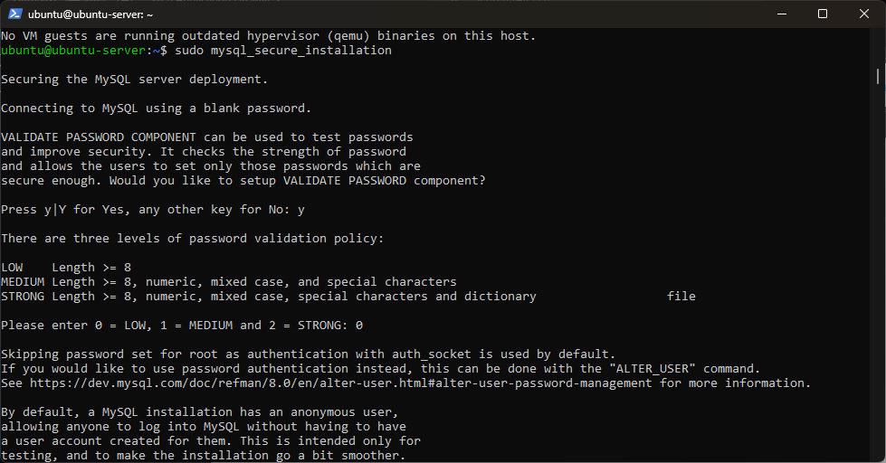
Figure 8 secure sql installation
4. Clone DVWA:
After that I cloned the DVWA by using following commands
cd /var/www/html
sudo git clone https://github.com/digininja/DVWA.git
sudo chown -R www-data:www-data DVWA
sudo chmod -R 755 DVWA
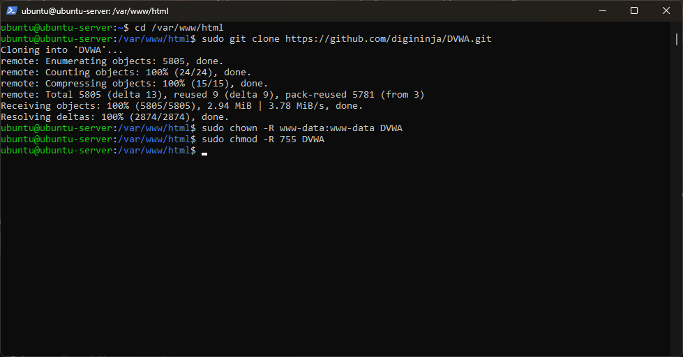
Figure 9 DVWA
5. Create the DVWA database and user in MySQL:
To create a DVWA database and user in SQL I ran this command
sudo mysql -u root -p
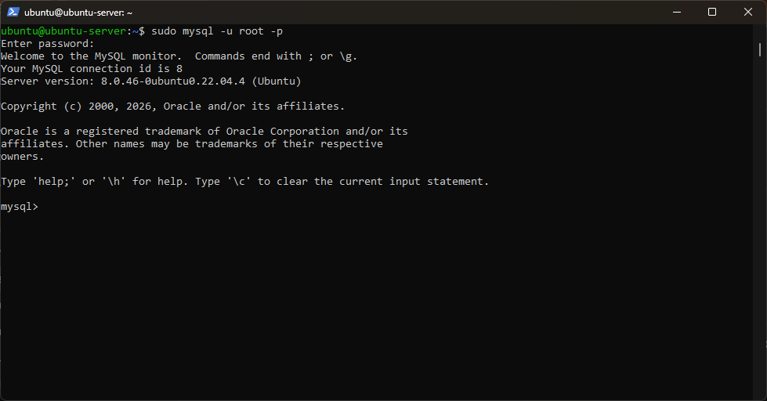
Figure 10 SQL
Then I ran these commands in the SQL to create the DVWA database and granting access

CREATE DATABASE dvwa;
CREATE USER 'dvwa_user'@'localhost' IDENTIFIED BY 'Dvwa@2026!';
GRANT ALL ON dvwa.* TO 'dvwa_user'@'localhost';
FLUSH PRIVILEGES;
exit;
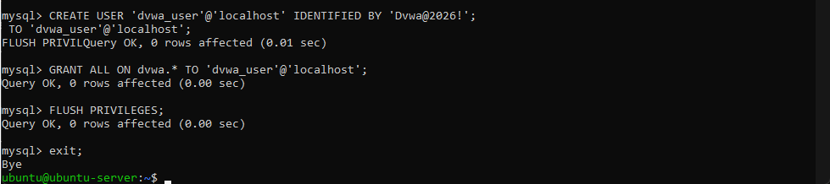
6. Configure DVWA's config file:
Then I copy the sample config to the real config file:
cp /var/www/html/DVWA/config/config.inc.php.dist /var/www/html/DVWA/config/config.inc.php

when I ran these command the permission get denied it because I typed the command without the sudo.

It happened because the DVWA folder's owned by www-data, not the ubuntu user, so a plain cp gets blocked.
To open the config file, I ran the sudo nano command with the file path.
sudo nano /var/www/html/DVWA/config/config.inc.php

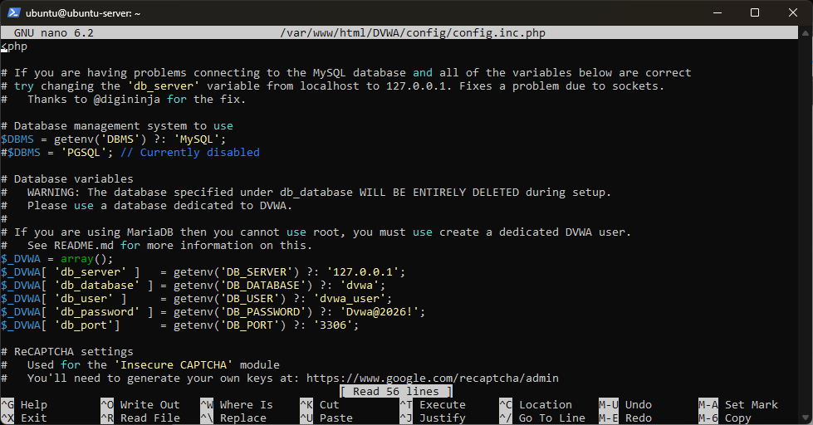
Figure 11 config file.
Sudo nano command opened the file then I find the following lines to update them to match what I just created
$_DVWA[ 'db_user' ] = 'dvwa_user';
$_DVWA[ 'db_password' ] = 'Dvwa@2026!';
$_DVWA[ 'db_database' ] = 'dvwa';
7. Change Apache's listening port to 8080 (so port 443/80 stays free for SafeLine later):
The next step is to change the Apache port to 8080 for this I edited the port config file by using the SUDO nano command along with the file path
sudo nano /etc/apache2/ports.conf
1. Edit the ports config:
I changed the listen 80 to listen 8080.
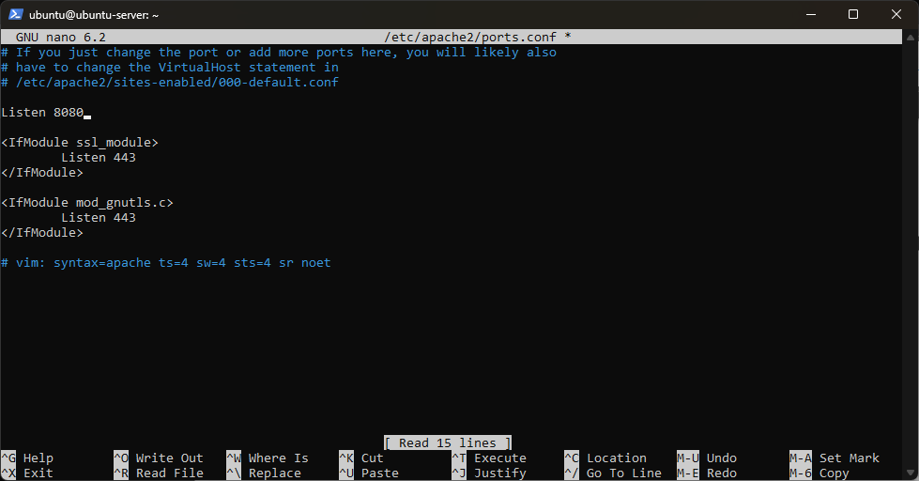
Figure 12 port config file
- Edit the default virtual host:
To edit the default virtual host open the file 000-default.conf by using the SUDO nano command
sudo nano /etc/apache2/sites-available/000-default.conf
I edited the <VirtualHost *:80> to <VirtualHost *:8080>
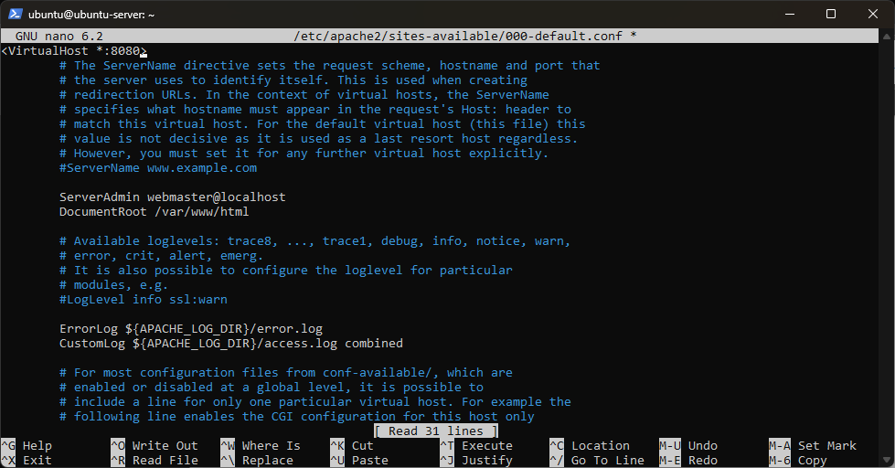
Figure 13 000-default.conf file
- Restart Apache:
I restarted the Apache with the following command
sudo systemctl restart apache2
Verify it's listening on 8080:
sudo ss -tlnp | grep apache2

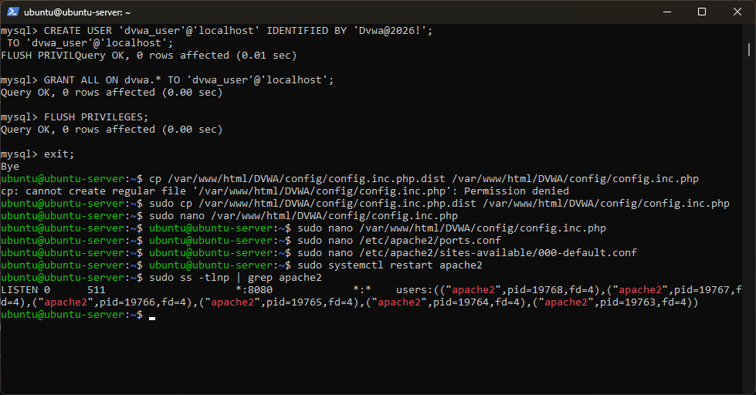
Figure 14 confirming Apache port
As its confirmed that it is running on port 8080 now we will initialize the DVWA from kali browser.
When I tried to initialize the DVWA in the kali I faced an error the php was not responding and when I checked the reason it was because of missing ? at the first line
It should be <?php — the ? is missing. Without it, PHP doesn't recognize this as a PHP file at all, so it just gets read as plain text — which is exactly why $_DVWA never gets set and everything downstream breaks.
After confirming the there is no syntax error in the PHP file I reinitialized the DVWA from kali browser
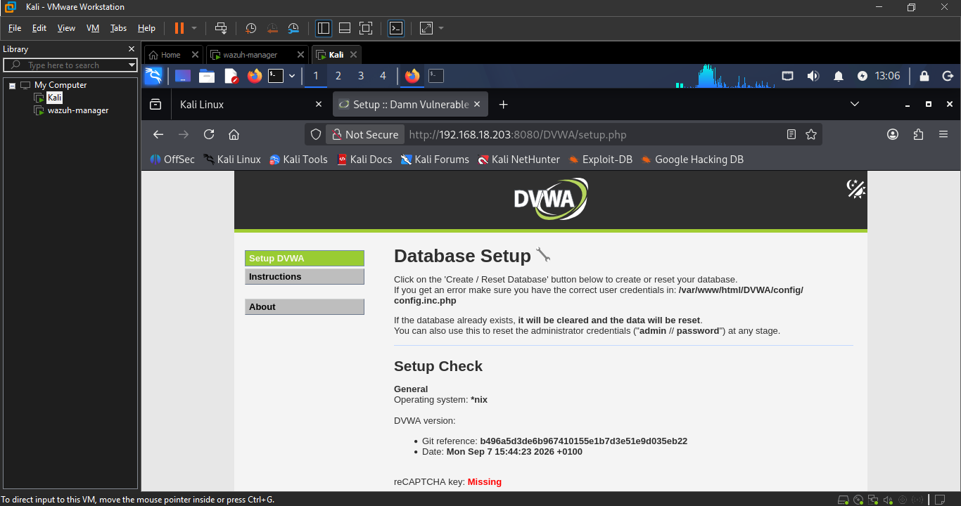
Figure 15 setup page
When I clicked on the create database button I faced the server 500 error to check for the reason I pasted the following command in the ubuntu
sudo tail -n 30 /var/log/apache2/error.log

What happened: MySQL vs. MariaDB syntax mismatch
The root cause: DVWA's setup script was written assuming the database backend is MariaDB, but you installed standard MySQL 8.0 (sudo apt install mysql-server gives you MySQL, not MariaDB — they're related but diverged projects with slightly different SQL dialects).
The specific issue: MariaDB supports a convenience clause called IF NOT EXISTS when adding a column to a table:
sql
ALTER TABLE users ADD COLUMN IF NOT EXISTS role VARCHAR(20) DEFAULT 'user';
This tells the database "only add this column if it doesn't already exist — otherwise skip it silently." Standard MySQL doesn't support this clause for ADD COLUMN (it was only added to MySQL in version 8.0.29 for a few specific DDL operations, and even then, not universally applied — DVWA's syntax still didn't match). Since your MySQL rejected the clause outright, it threw:
ERROR 1064: You have an error in your SQL syntax
which PHP then surfaced as an uncaught exception → Apache 500 error → blank/broken page in the browser.
The fix: Remove IF NOT EXISTS from both occurrences (role column and account_enabled column) in MySQL.php. Since it was a fresh database each time, the columns genuinely didn't exist yet, so the safety clause wasn't needed — a plain ADD COLUMN worked fine.
After running the http://192.168.18.203:8080/DVWA/setup.php in the kali browser and making sure DVWA is working properly I clicked on the create / reset database button then the following login form was displayed
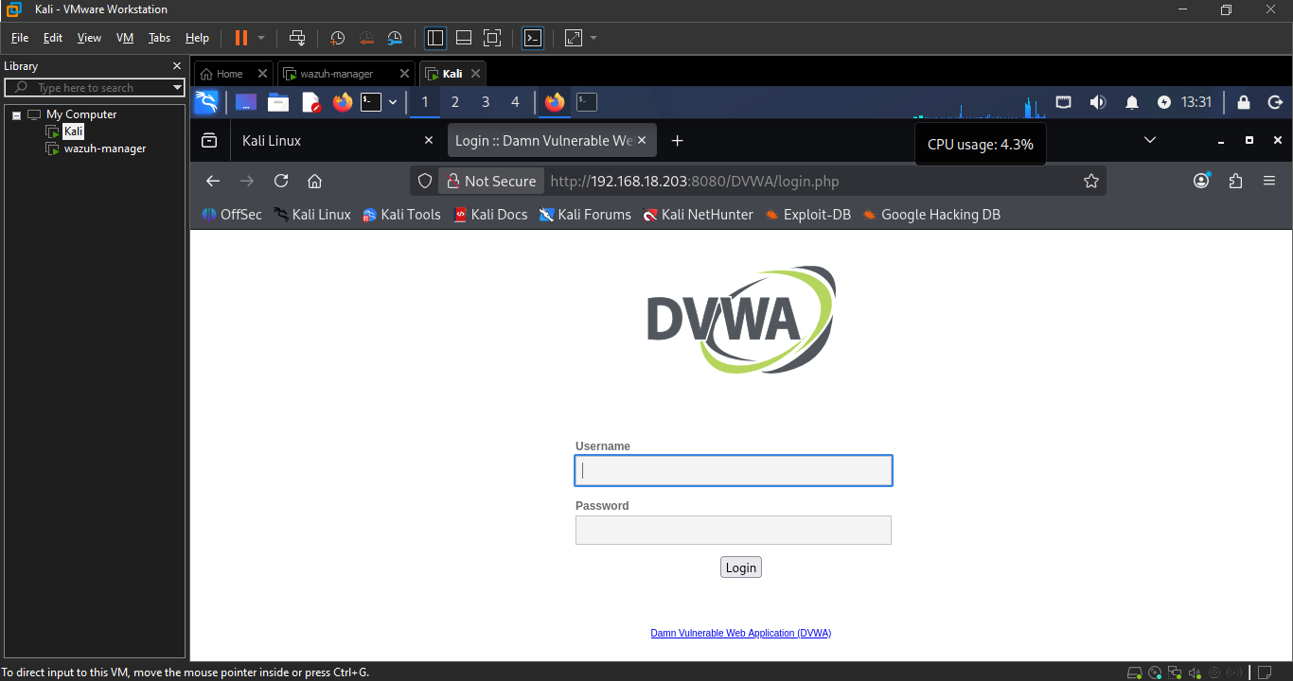
Figure 16 DVWA login form
Verify: sudo ss -tlnp | grep apache2 shows Apache listening on 8080. Browser loads http://<Ubuntu-IP>:8080/DVWA/setup.php and "Create/Reset Database" succeeds without a 500 error, landing on the DVWA login page

Phase 3: DNS Resolution (/etc/hosts)
- First, I log into DVWA to confirm everything's working end-to-end by using the
Username: admin
Password: password
- On Ubuntu, add the domain mapping:
sudo nano /etc/hosts
Add this line at the bottom:
192.168.18.203 dvwa.local
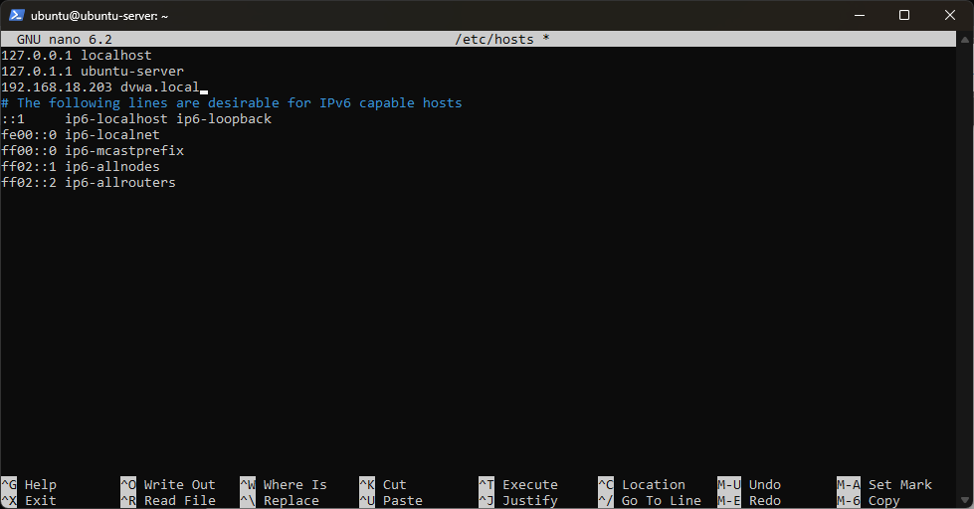
Figure 17 ubuntu host

- On Kali, do the same:
sudo nano /etc/hosts
Add the identical line:
192.168.18.203 dvwa.local
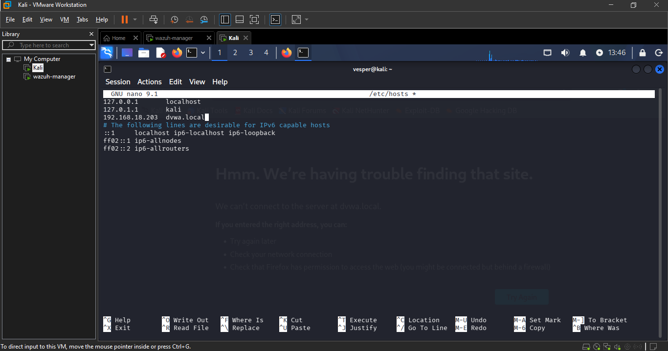
Figure 18 kali host file
- Test it — from Kali's Firefox, go to:
http://dvwa.local:8080/DVWA/
the DNS is working properly as the following link is working properly
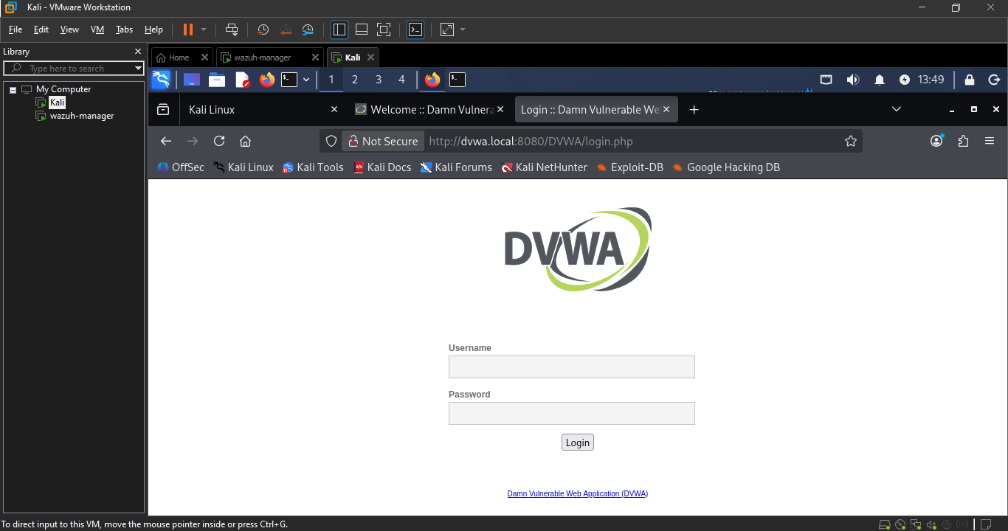
Figure 19 DNS test verification
Verify: http://dvwa.local:8080/DVWA/ loads identically to the IP-based URL, on both Kali and Ubuntu's own hosts file.

Phase 4: Self-Signed SSL Certificate
- Create a directory for the cert files:
to create a directory for the cert file use the following command
sudo mkdir -p /etc/ssl/dvwa

- Generate the private key, CSR, and self-signed certificate in one step:
use the following commands to generate the certificate
sudo openssl req -x509 -nodes -days 365 -newkey rsa:2048 \
-keyout /etc/ssl/dvwa/dvwa.key \
-out /etc/ssl/dvwa/dvwa.crt
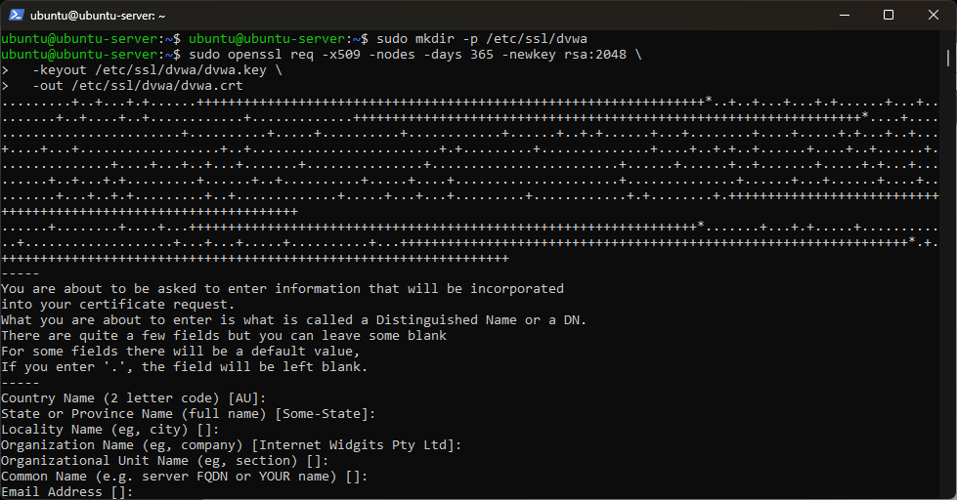
Figure 20generating certificates
- Verify both files were created:
ls -l /etc/ssl/dvwa/
- Quick look at the cert to confirm it generated correctly:
openssl x509 -in /etc/ssl/dvwa/dvwa.crt -text -noout | head -20
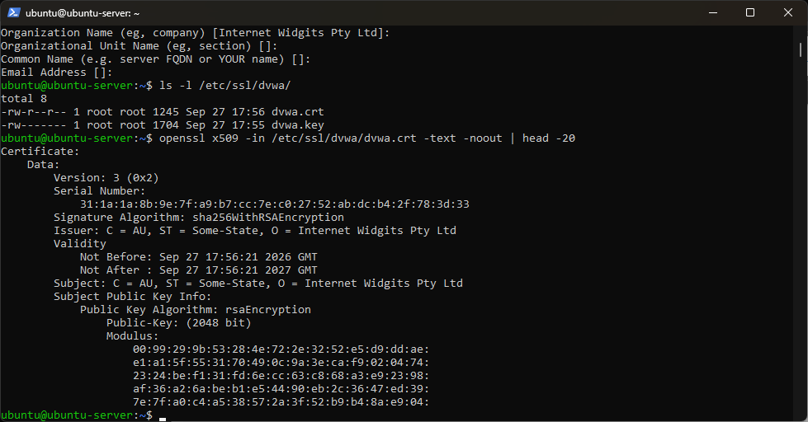
Verify: ls -l /etc/ssl/dvwa/ shows both dvwa.crt and dvwa.key. openssl x509 -in dvwa.crt -text -noout shows CN = dvwa.local in the Subject line (not a blank/default value).

Phase 5: Installing SafeLine WAF
- Run the automatic install script:
To run the automatic install scripts I ran the following command in the ubuntu server
bash -c "$(curl -fsSLk https://waf.chaitin.com/release/latest/manager.sh)" -- --en
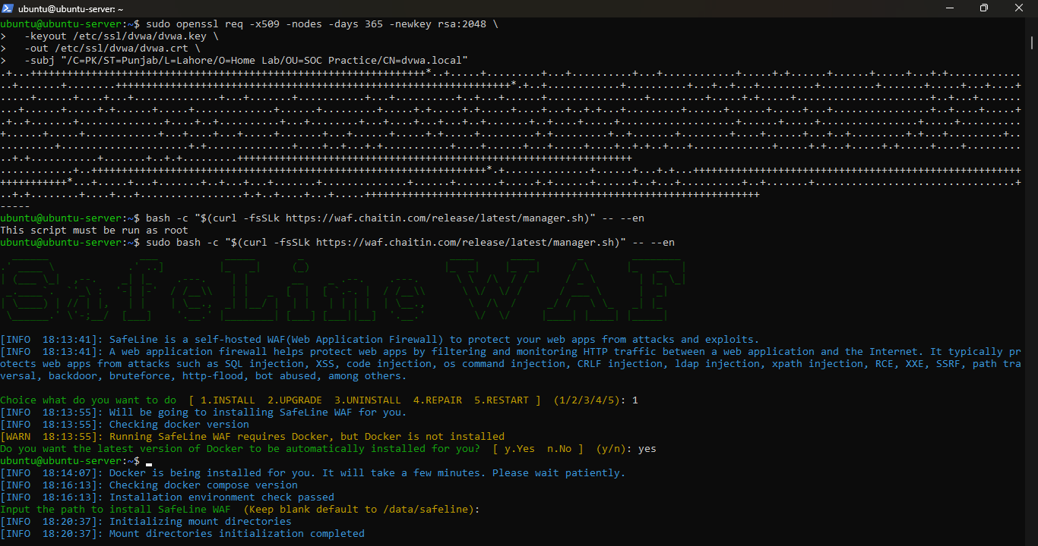
Figure 21 SafeLine installation.
5. Once installed, open it from Kali's Firefox:
After completing the installation save the username and password and run this https://192.168.18.203:9443 in kali firefox
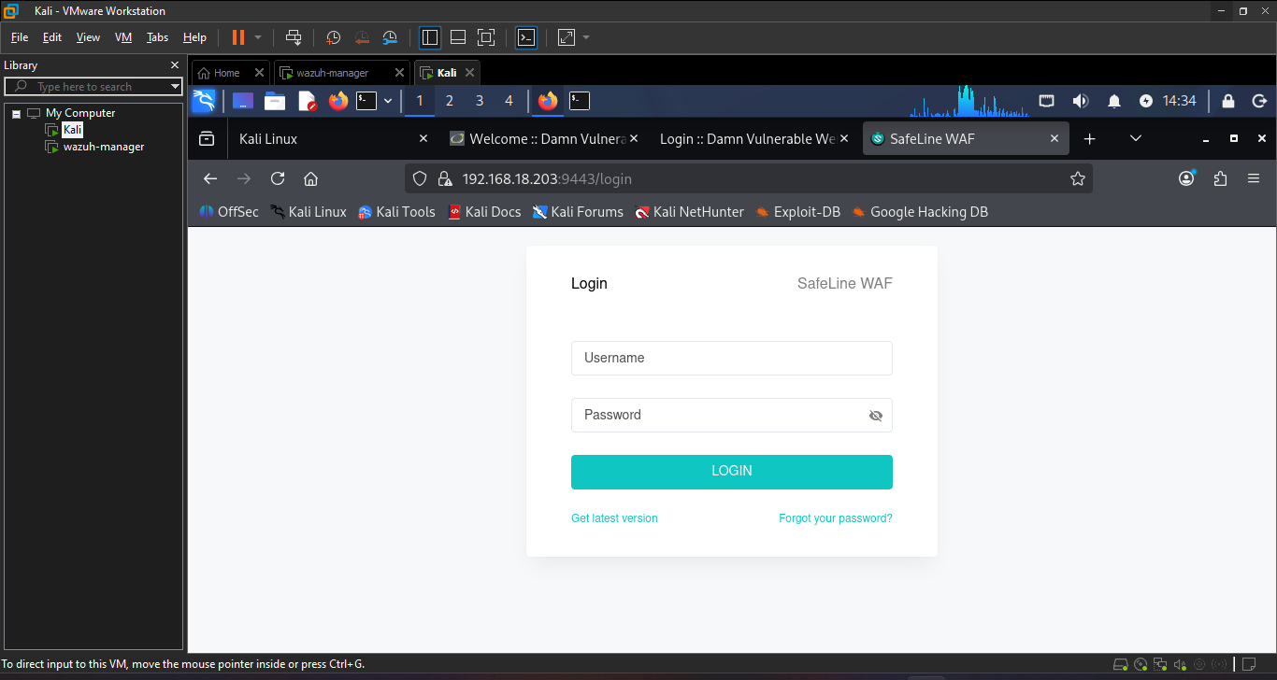
Figure 22 safeline login page
After entering the password and username safeline dashboard appeared
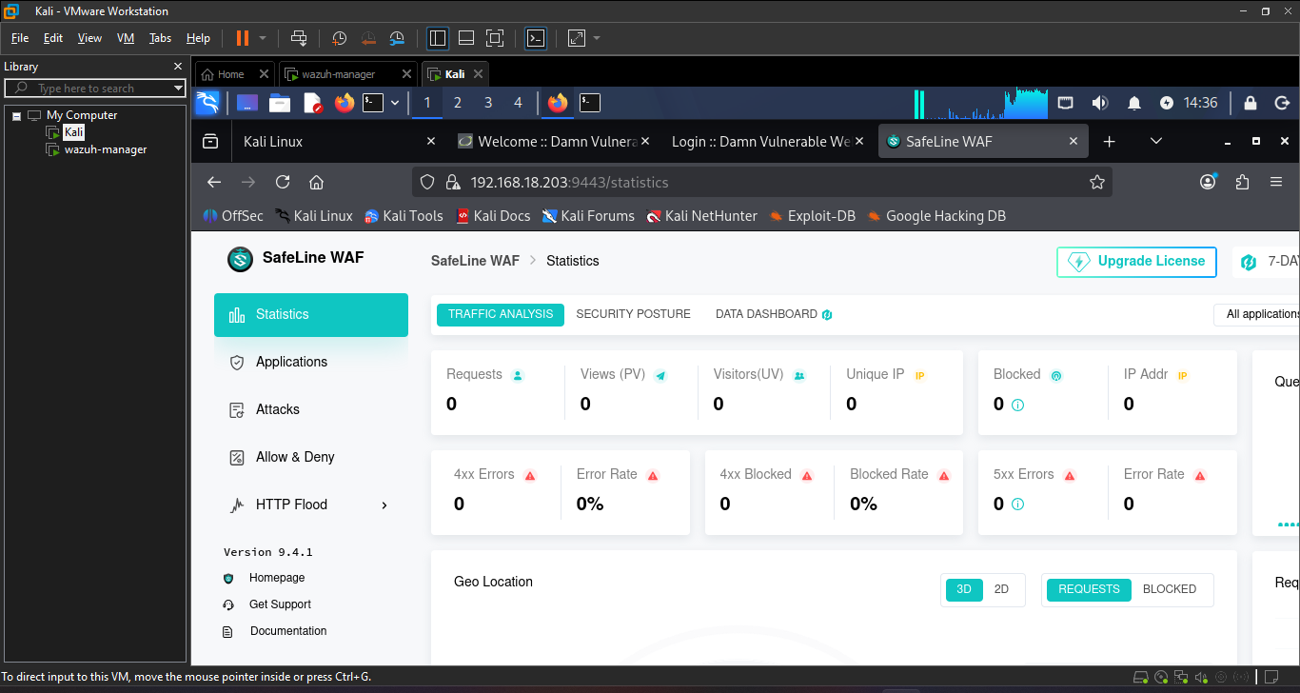
Figure 23 safeline WFA Dashboard
Verify: sudo docker ps shows all SafeLine containers (mgt, tengine, detector, postgres, fvm, chaos, luigi) with status Up. https://<Ubuntu-IP>:9443 loads the SafeLine login page.

Phase 6: Import the SSL Certificate + Onboard DVWA:
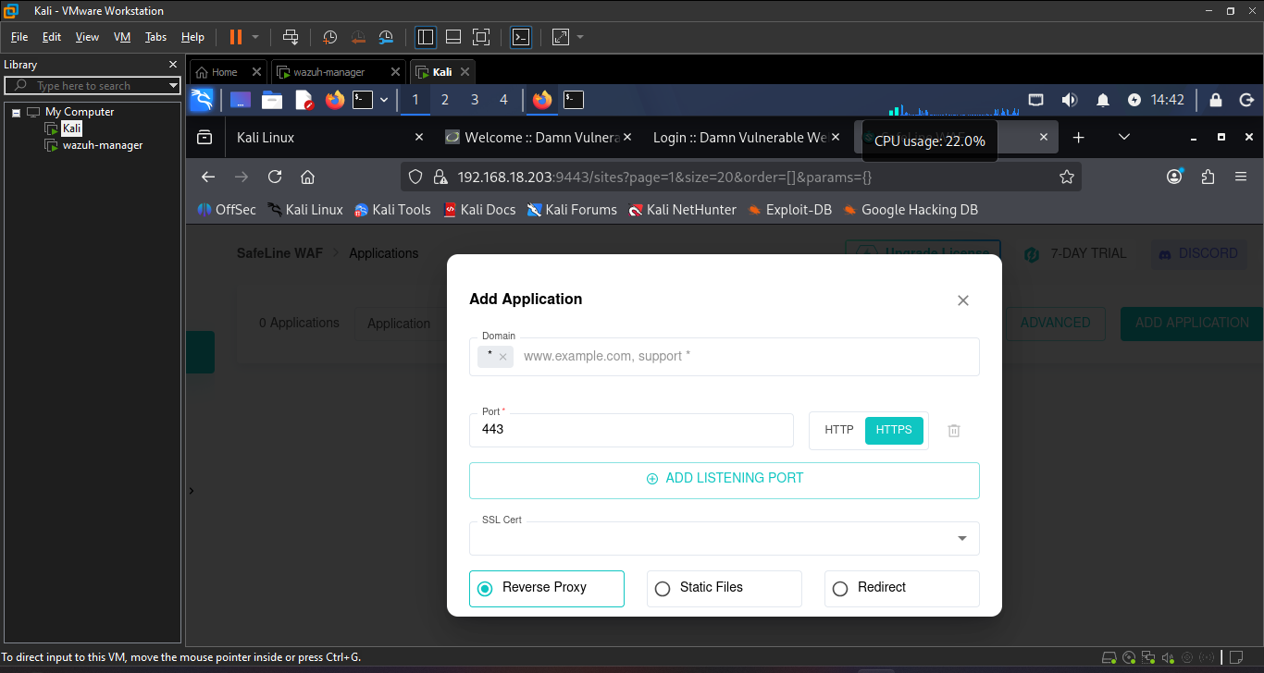

Steps taken:
- I Navigated to SafeLine's Applications → Add Application → Add Cert.
- Then Attempted to paste certificate/key contents directly into the text fields via copy-paste from an SSH terminal → failed with tls: failed to find any PEM data in certificate input (multi-line PEM content gets corrupted by terminal-to-browser clipboard sync).
- Fix: transferred the cert and key files directly between VMs using scp instead of copy-paste, then used SafeLine's file upload buttons rather than pasting text.
  - Cert file copied over cleanly on first attempt.
  - Key file initially failed (Permission denied) — dvwa.key was created with 600 permissions, root-owned. Fixed by copying it to the ubuntu user's home directory with correct ownership before transferring, then deleting the copy afterward.
- Certificate uploaded successfully and matched to dvwa.local (Match All Host).
- Completed the Add Application form:
  - Domain: dvwa.local
  - Port: 443 (HTTPS only, port 80 removed)
  - SSL Cert: the uploaded certificate
  - Mode: Reverse Proxy
  - Upstream: initially set to 127.0.0.1:8080 → rejected, since SafeLine runs inside Docker and 127.0.0.1 inside a container refers to the container itself, not the Ubuntu host. Corrected to the host's real IP.
  - Upstream further corrected to http://192.168.18.203:8080 — SafeLine requires a full URL with scheme (http://), not a bare host:port, which otherwise throws: parse "192.168.18.203:8080": first path segment in URL cannot contain colon.
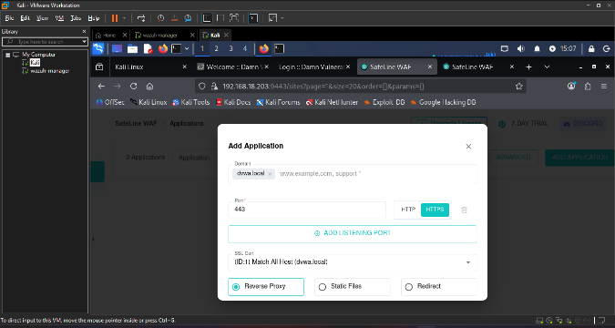
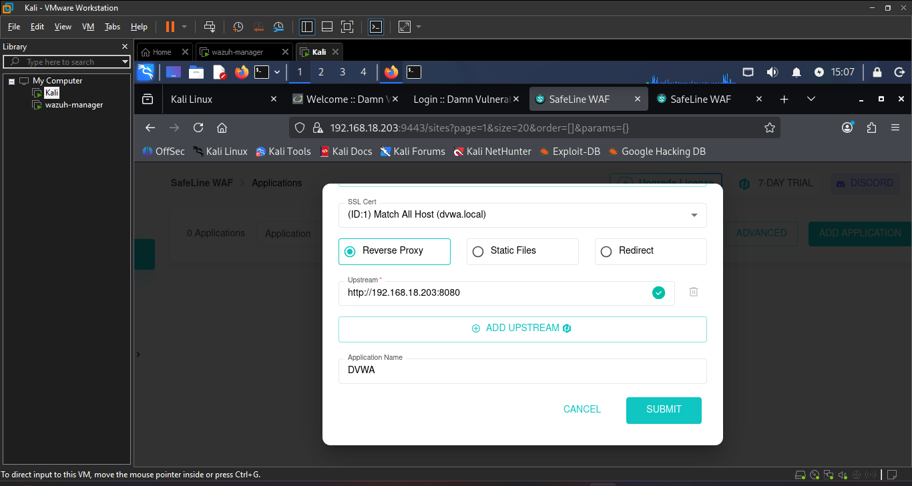

After making sure DVWA is registered as a protected application domain dvwa.local, port 443/HTTPS, defense toggle showing green. Phase 6's core config is done.
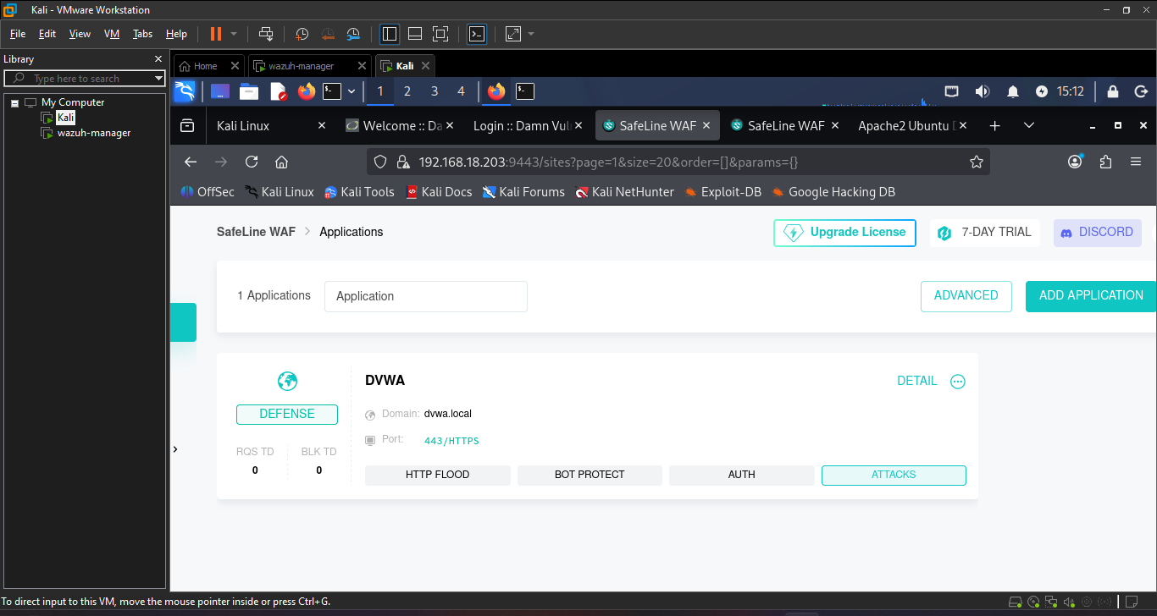
Figure 24 DVWA is registered and protected
When I try the https://dvwa.local in kali FireFox it landed on the SafeLine is correctly forwarding to Apache on port 8080, but it's landing on Apache's document root (/var/www/html/), which still has its default index.html.
Fix: make Apache redirect the root straight to /DVWA/
1. On Ubuntu, edit the default site config:
sudo nano /etc/apache2/sites-available/000-default.conf
2. Add this line inside the <VirtualHost *:8080> block (anywhere between the opening and closing tags):
Redirect /DVWA
Wait — more precisely, add:
RedirectMatch ^/$ /DVWA/
This tells Apache: "any request to exactly / gets redirected to /DVWA/."
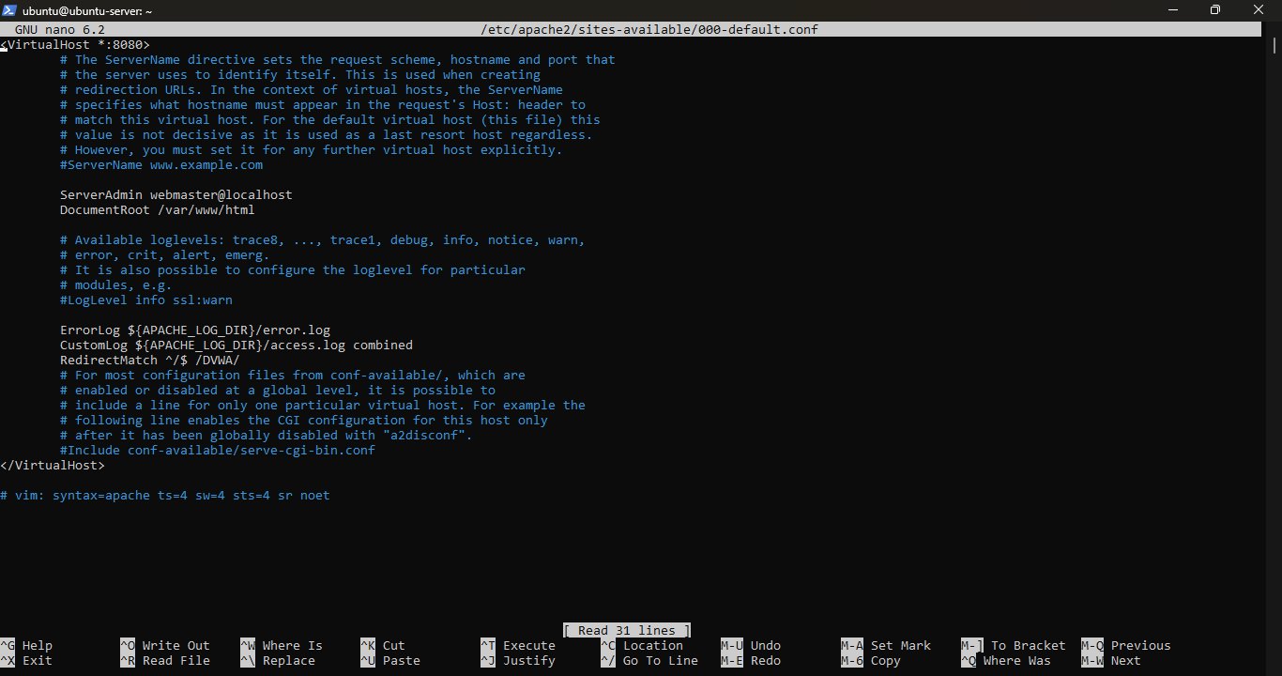
3. Save and exit (Ctrl+O, Enter, Ctrl+X).

4. Restart Apache:
sudo systemctl restart apache2
5. Retest from Kali:
https://dvwa.local

it says http://dvwa.local:8080/DVWA/login.php, not https://dvwa.local. That means you're looking at DVWA directly through Apache again — the request never went through SafeLine at all. The RedirectMatch we added is the culprit.
Why: Apache doesn't know it's sitting behind a reverse proxy. When it issues that redirect, it builds the destination URL using its own port (8080), not SafeLine's (443). So the browser followed the redirect straight to Apache, completely bypassing the WAF — which defeats the whole point of this lab.
Better fix: skip the redirect entirely — just serve DVWA directly at the root, since this Apache instance only needs to serve DVWA anyway.
1. Undo the redirect and change the DocumentRoot instead:
sudo nano /etc/apache2/sites-available/000-default.conf
Remove the RedirectMatch line you added, and change:
DocumentRoot /var/www/html
to:
DocumentRoot /var/www/html/DVWA
2. Save and exit (Ctrl+O, Enter, Ctrl+X).
3. Restart Apache:
sudo systemctl restart apache2
4. Test again — but this time, clear the address bar completely and type the full URL explicitly:
https://dvwa.local

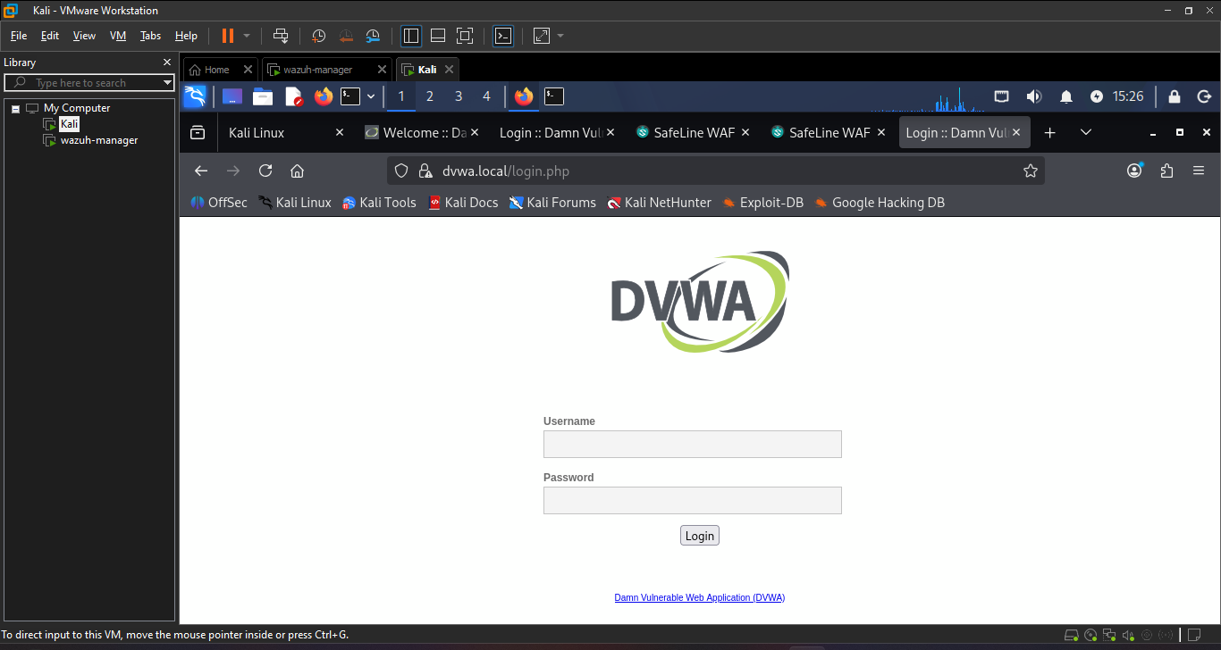
Figure 25 DVWA with safeline configured
That address bar is exactly what I wanted dvwa.local/login.php with the padlock, no port number showing (meaning it's on port 443, HTTPS). That confirms traffic is routing the full path: Kali → SafeLine (443) → Apache (8080) → DVWA. Phase 6 is completed.
Verify: https://dvwa.local (no port shown in address bar, padlock icon present) loads DVWA's login page directly confirming traffic is routed Kali → SafeLine (443) → Apache (8080) → DVWA, not bypassing the WAF.
Phase 7: SQL Injection Demonstration:
Now I am going to prove that the WFA actually works
- Log into DVWA through https://dvwa.local with admin / password.
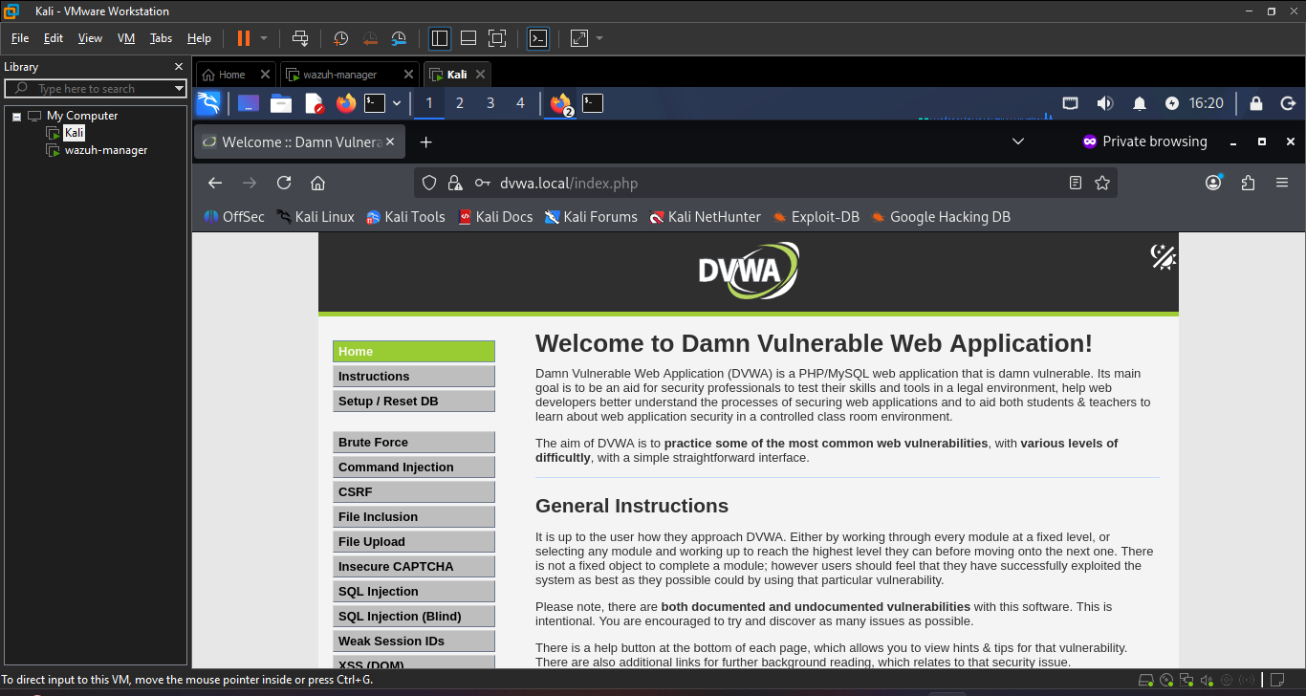
Figure 26 DVWA Dashboard
- Set the security level to low:
- I Clicked DVWA Security in the left sidebar
- And Select Low, then click Submit

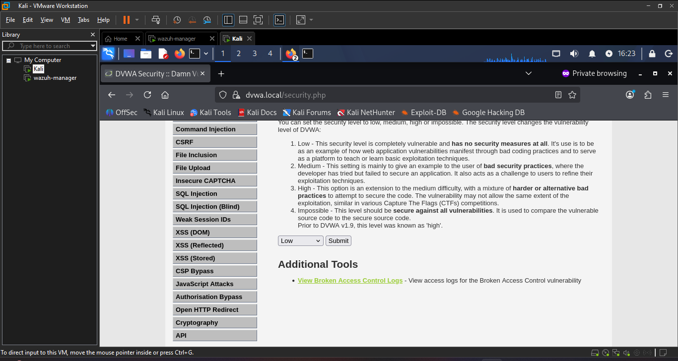
Figure 27 selecting DVWA security as low
3. Go to the SQL Injection module in the left sidebar.
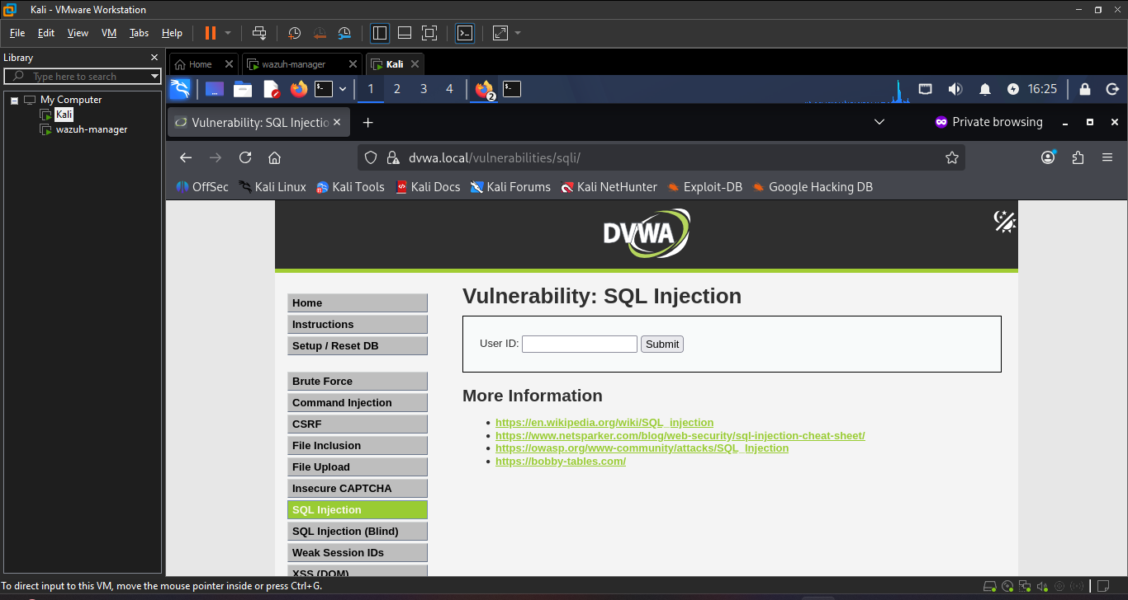
Figure 28 sql injection page of DVWA
4. In the User ID field, try:
' OR '1'='1
Click Submit.
Safeline WAF blocked this action

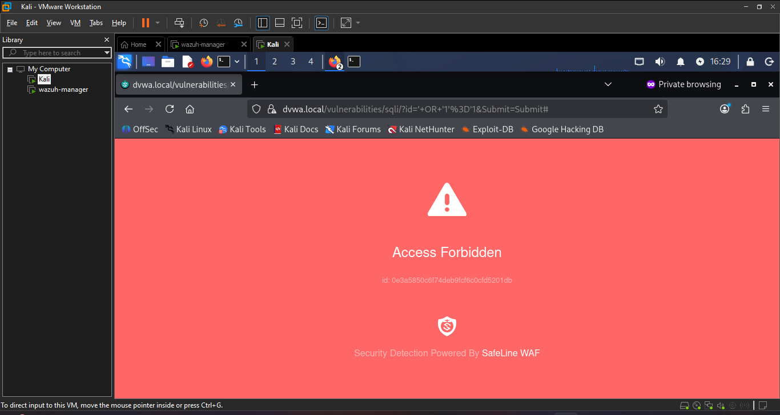
Figure 29 Safeline blocking the SQL injection attempt
As you can see in screenshot the safeline WAF blocked the SQL injection attempt
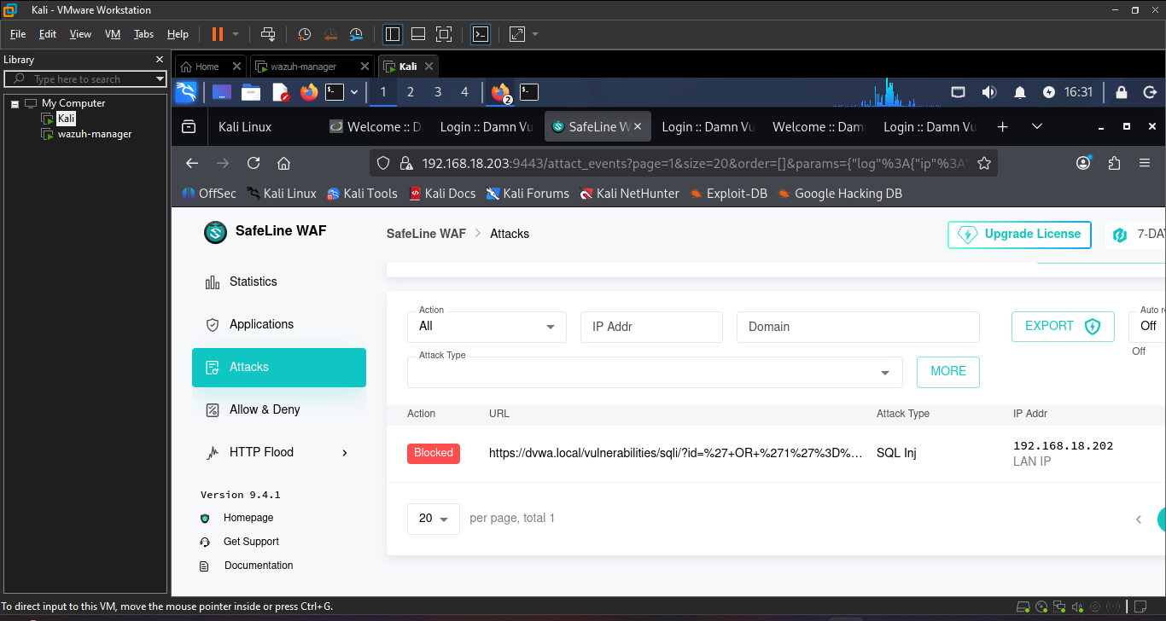
Figure 30 safeline WAF blocking SQL injection
Step 2: Disable SQLi protection temporarily
- Go to SafeLine → Applications → DVWA → ATTACKS tab
- I Found the SQL Injection rule and set it to Disabled (just for this specific check not the whole WAF).
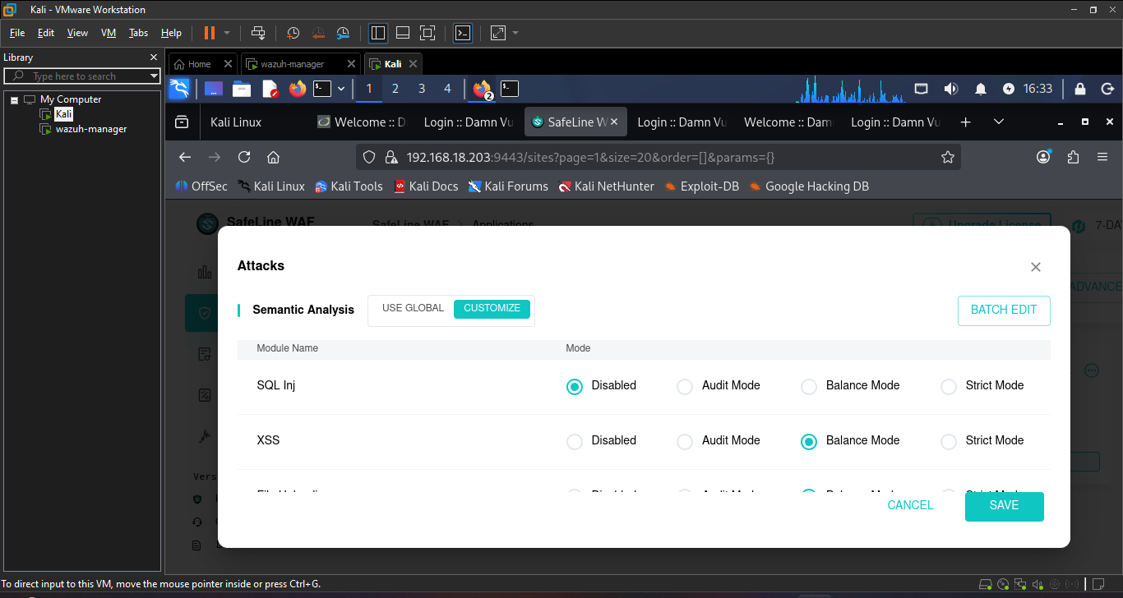
Figure 31 Disabling SQL injection in safeline
3. Go back to Kali's Firefox and retry the exact same payload:
' OR '1'='1
on the SQL Injection page.
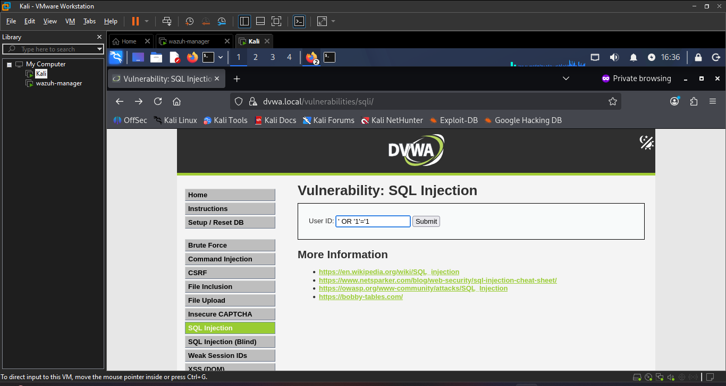
Figure 32 trying SQL injection on DVWA
Expected result this time: the request goes through, and DVWA returns all user records from the database (since the injected OR '1'='1' makes the WHERE clause always true) — proving the underlying app is genuinely vulnerable, not just that SafeLine blocks random-looking input.
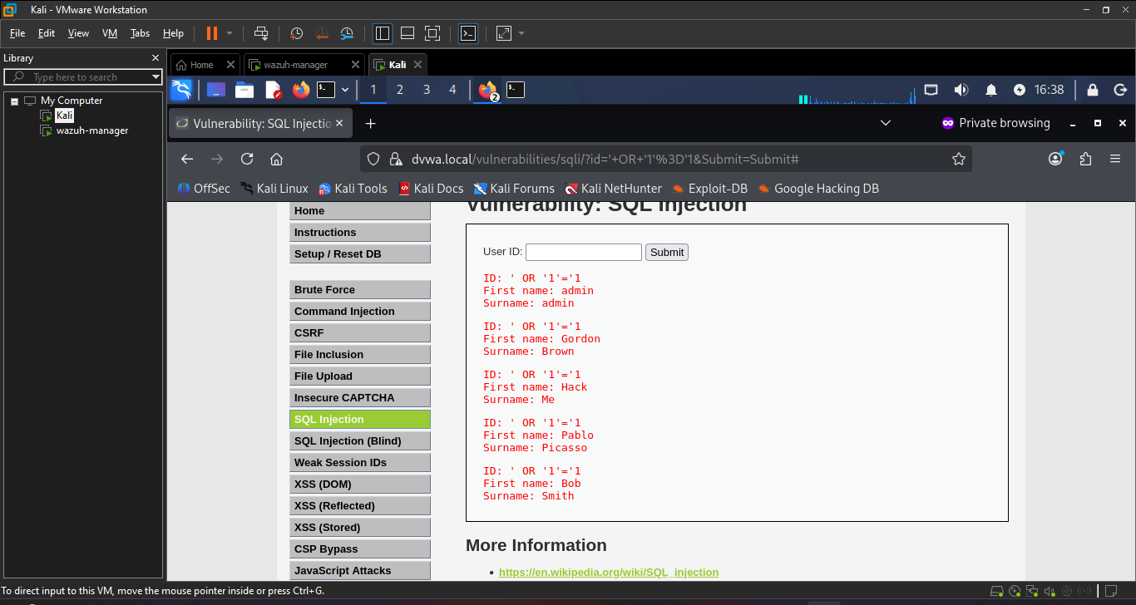
Figure 33 Successful SQL injection on DVWA
Last step: re-enable protection and confirm it's blocked again:
1. Go back to SafeLine → Applications → DVWA
2. Re-enable it (set back to whatever mode it was — likely "Balance" or the default).
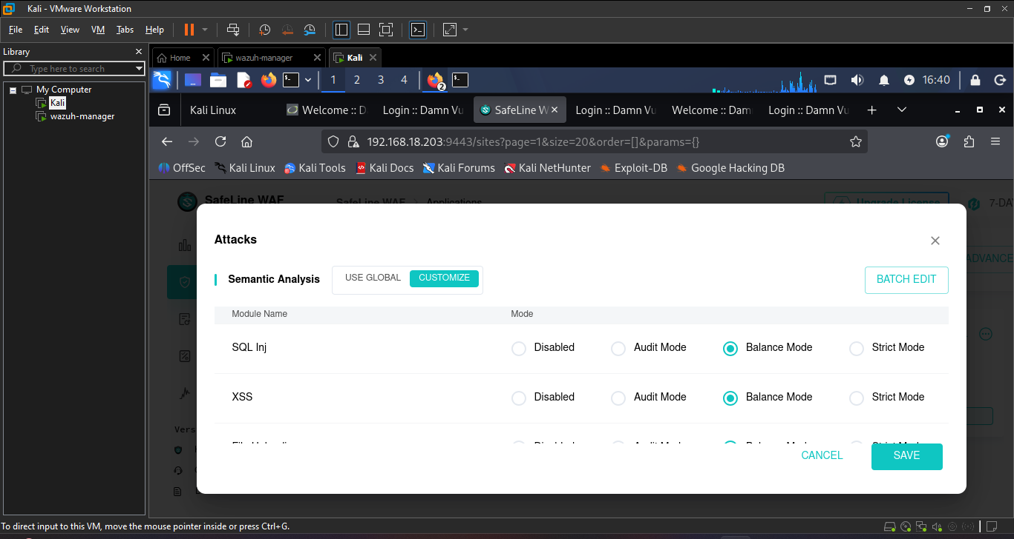
Figure 34 Again enabling SQL injection protection
3. Retry the exact same payload on the SQL Injection page:
' OR '1'='1
Expected: back to "Access Forbidden," same as my first test.
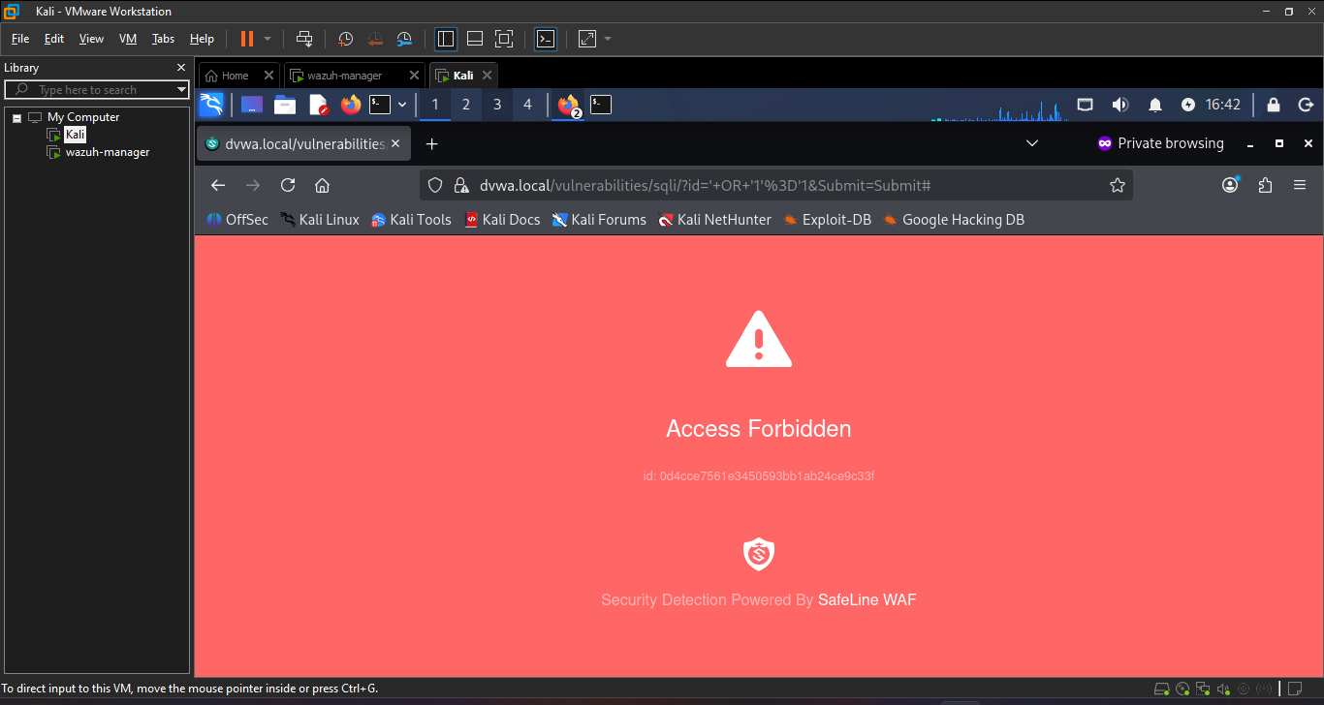
Figure 35 WFA is working
Verify (three-part): payload blocked with protection on → same payload succeeds (dumps user table) with protection off → payload blocked again once protection is restored. All three states should be screenshotted as evidence

Phase 8: Advanced WAF Configurations
8.1 HTTP Flood Defense (rate limiting)
- In SafeLine, I find the HTTP Flood settings for the DVWA app.
- Set something demonstrable: e.g. 3 requests within 10 seconds → block for 5 minutes.
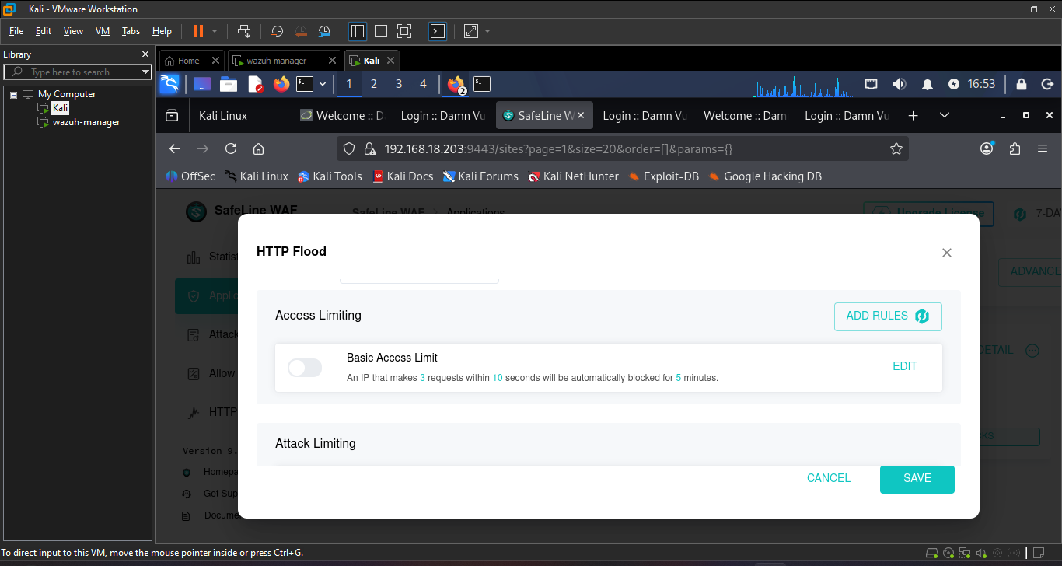
Figure 36 http flood
From Kali, try accessing https://dvwa.local again — SafeLine itself should now prompt for credentials before even reaching DVWA's own login page (an extra auth layer in front of the app).
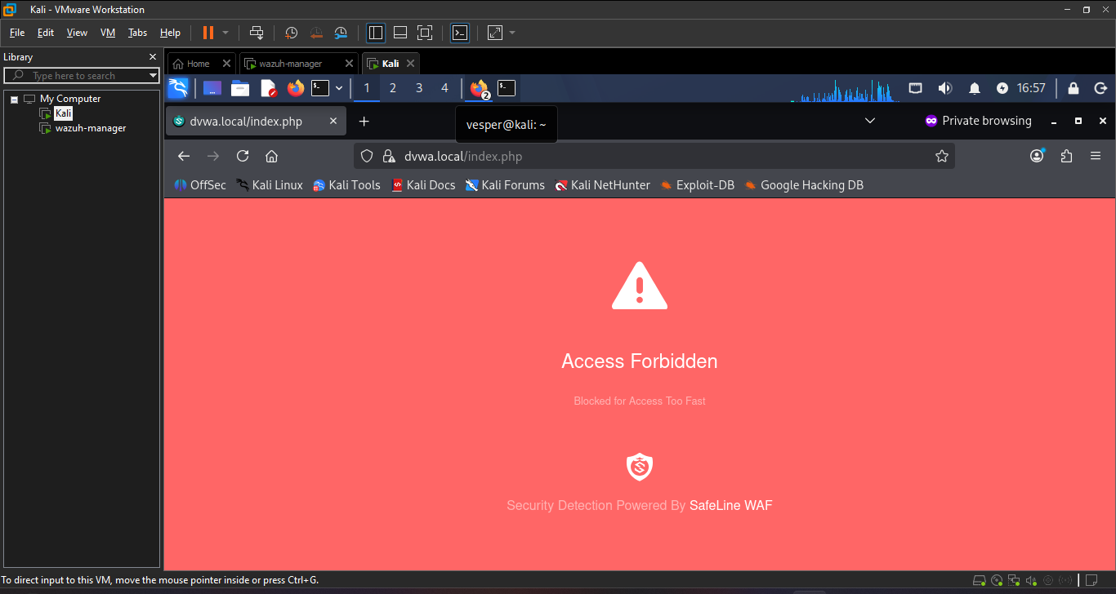
Figure 37 blocked because of HTTP flood
Verify: rapid repeated requests (manual refresh or ab/siege) trigger a block message after the configured threshold, and SafeLine's HTTP Flood log shows the block event with timestamp and source IP.
8.2 Authentication Gateway
- In SafeLine, I enabled Auth Sign-In for the DVWA application.
- Set up a simple username/password (e.g. admin/waftest123).
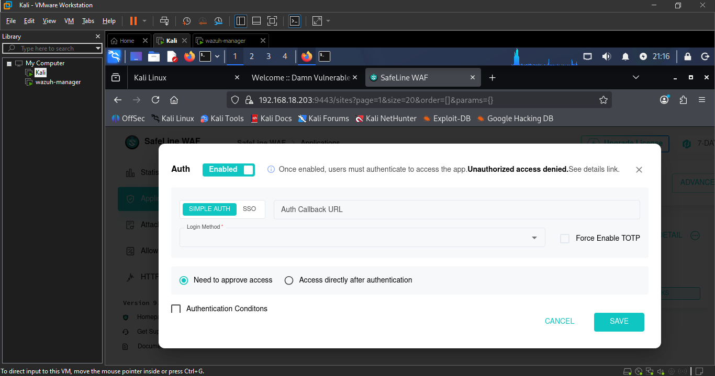
Figure 38 Auth in safeline WAF
The screenshot proves that auth is working properly
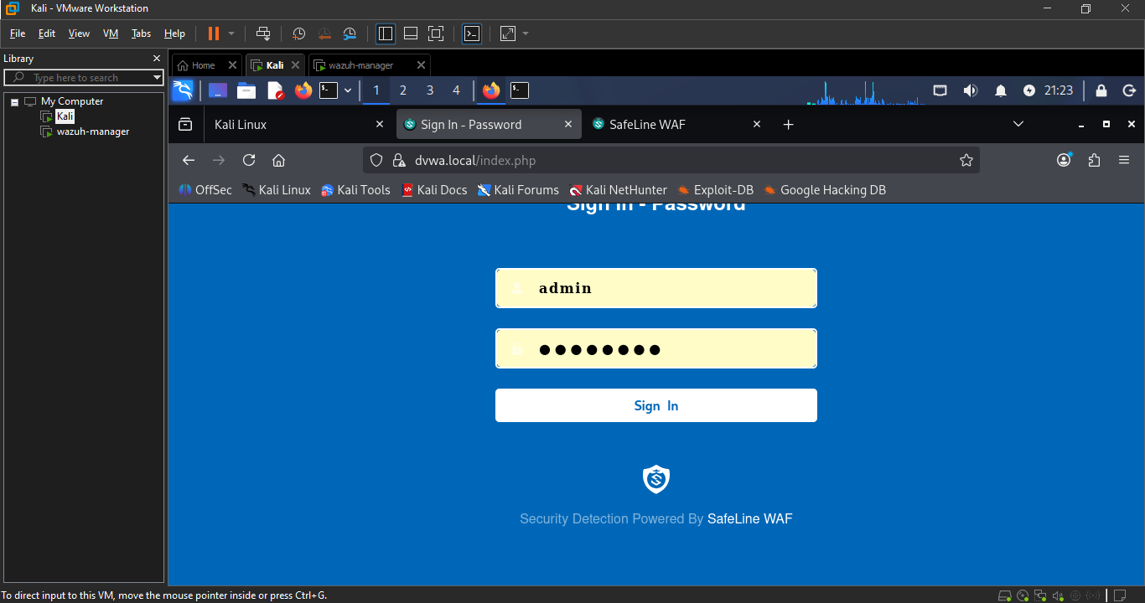

Setting up the new user and password
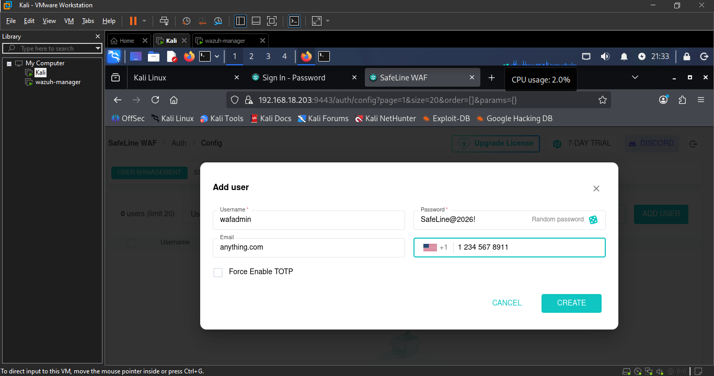
Figure 39 adding user

Now I am in with new username and password
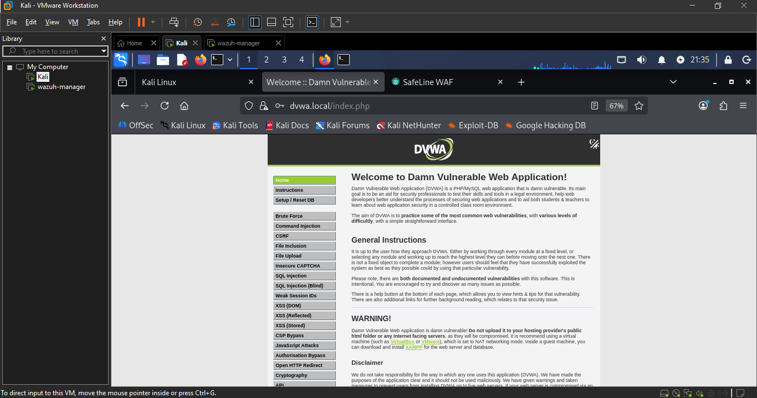
Verify: accessing https://dvwa.local in a fresh/private browser session prompts for the SafeLine-level sign-in before DVWA's own login page appears; correct credentials pass through to DVWA, incorrect ones are rejected at the WAF layer.
Challenges faced:
Challenge #1: Permission denied on the copy command
Running cp to copy DVWA's sample config file into place failed with "Permission denied." Cause: the DVWA folder is owned by www-data, not the ubuntu user, so a plain cp command gets blocked. Fixed by re-running the command with sudo. See Phase 2 (4) for the full fix.
Challenge #2: Missing <?php tag:
DVWA's setup page failed to load because the config file's opening tag was typed as <php instead of <?php, so PHP never parsed the file and $_DVWA was never defined. See Phase 2 (4) for the full fix.
Challenge #3: MySQL vs. MariaDB syntax mismatch:
Clicking "Create Database" threw a 500 error because DVWA's setup script uses ADD COLUMN IF NOT EXISTS, a MariaDB-only clause not supported by standard MySQL 8.0. Fixed by removing IF NOT EXISTS from both occurrences in MySQL.php. See Phase 2 (4) for the full fix
Challenge #4: Redirect bypassing the WAF
An Apache Redirect Match rule meant to send / to /DVWA/ backfired Apache issued the redirect using its own port (8080), sending the browser straight to Apache and skipping SafeLine entirely. Fixed by setting Apache's Document Root to /DVWA directly instead of redirecting. See Phase 6 (17) for the full fix.

Challenge #5 The login debugging challenge :
After onboarding DVWA into SafeLine, logging in through https://dvwa.local silently failed the page just reloaded with the same credentials, no error, nothing in Apache's logs.
Ruled out, one by one:
- WAF blocking it checked SafeLine's attack logs, nothing there.
- Bot protection interfering confirmed it was disabled.
- Session not persisting used Firefox DevTools to trace the login POST → redirect chain, compared PHPSESSID across requests — matched fine.
- PHP failing to write sessions inspected the actual session file on disk (/var/lib/php/sessions/sess_...) confirmed DVWA was correctly saving username: admin server-side.
- A PHP code bug traced DVWA's login/auth-check functions in the source to rule out something like a missing reference (&) that could silently break session writes code was fine.
Actual cause: none of it was a real bug just stale, conflicting cookies left over from the many earlier test requests made directly against Apache and through the WAF during setup. A fresh private-browsing session cleared it instantly.

SafeLine WAF + DVWA Home Lab Summary:
What you built: A working web application firewall setup where SafeLine WAF sits in front of a genuinely vulnerable app (DVWA), running across two VMs — Kali (attacker, GUI) and Ubuntu (victim, headless).

Phases completed
Phase | What happened
1. Networking | Kali (192.168.18.202) and Ubuntu (192.168.18.203) confirmed reachable on the same subnet
2. LAMP + DVWA | Apache/PHP/MySQL installed, DVWA deployed on port 8080 — hit and fixed a real MySQL vs. MariaDB syntax bug in DVWA's own code (ADD COLUMN IF NOT EXISTS)
3. DNS | /etc/hosts entries mapping dvwa.local to the Ubuntu server on both VMs
4. SSL Certificate | Self-signed cert generated via OpenSSL, CN set to dvwa.local
5. SafeLine Install | WAF deployed via Docker, admin dashboard live on port 9443
6. Onboarding | Cert imported, DVWA registered as a protected reverse-proxy app — worked through a few real gotchas: PEM paste corruption (fixed via scp), Docker's 127.0.0.1 not meaning the host, SafeLine needing a full URL not just host:port, and a redirect that accidentally bypassed the WAF entirely
7. Attack Demo | The centerpiece: SQL injection blocked → same payload succeeds with protection off (dumped the whole users table) → blocked again with protection restored
8. Advanced Config | Attempted the Auth gateway and HTTP flood.

